THE April 27,1935

Salinas Times

Spreading news throughout the good town of Salinas
s

Man Breaks married woman’s neck. Flees the scene.

By: William Lester
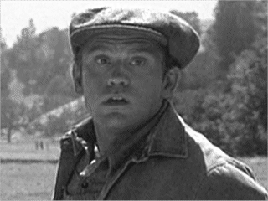
Photo taken by Jack Faraday with a Voigtländer Bergheil
SALINAS-Lennie Small is under suspicion for the murder of Susan Tyler yesterday in the late afternoon at “Tyler Ranch”.

It occurred in the south barn around 3:00pm. According to the eyewitness Jack Faraday “He Showed no remorse just killed her an’ ran.” He also took a picture of Small however it is very vague and does not present any new proof or show him murdering the victim.

However the laborers on the ranch like Candy Jones say otherwise. Candy Jones claims “Lennie could have never done it he’s as sweet as Aunt Jemima”.

The Police Chief, Daniel Gumshoe stated that “The autopsy seems suggests an instantaneous death from a broken neck.” and that it “would have required an extremely large man like that of Small”.

Susan Tyler is the wife of Curley Tyler who is the son of Nick Tyler. They all work at “Tyler Ranch” which Small recently joined with his partner George Milton.

Small has been connected to a case in Weed, Siskiyou County where there was a reported assault charge placed on Small. However a lack of proof this charge forced police to drop their search.

Any motive is currently unknown but his is reportedly “Mentally Handicapped” and could have had gone insane due to the immense pressure working on this farm has caused him. He also has been known to have a delusion about living on a farm obsessed with rabbits a clear symptom of Schizophrenia.

The police are currently searching for Small to question him on his involvement in the current case. If you see a man that resembles the picture above please alert the police immediately.
The police are also asking any other possible witnesses of the crime to please come to the sheriff’s office promptly.

